HUMA 1301 – Thompson

Language of Faith Project

As we have learned this semester, the art that accompanies cultures of faith is rich in symbolism and extended meaning beyond the images depicted.

For this project, you will choose a piece of religious art produced between the time period of 1 CE (the birth of Christ) to 1300 CE, and analyze the symbolism that you find in it. You can choose a work of art from one of the following religions:
- Christianity
- Islam
- Buddhism
- Hinduism
- Judaism

A successful project will have all of the following:
- Description of the work, including title, estimated time period of production, size, and where it is found (that is, in a museum or on a building, like a cathedral or mosque – see pg 313, Figure 13.25 in your textbook for an example)
- Source where you found the work
- A short description of what the work is and what it depicts.
- A list of all the symbols or religious figures used in the work (see page 207 for an example)
- A short description of how the symbols and figures convey the beliefs of that faith culture
While you may choose a work that is in your textbook, the maximum points for those who do will be 90 out of 100. Moreover, you may not use the works depicted on the following pages:
- Pg 207
- Pg 304
- Pg 313
- Pg 322
- Pg 328
Here is a very short example of this with a non-religious artifact. I expect yours to be a little more filled out than this example, but in case you were wondering what the final product should look like, please see below.

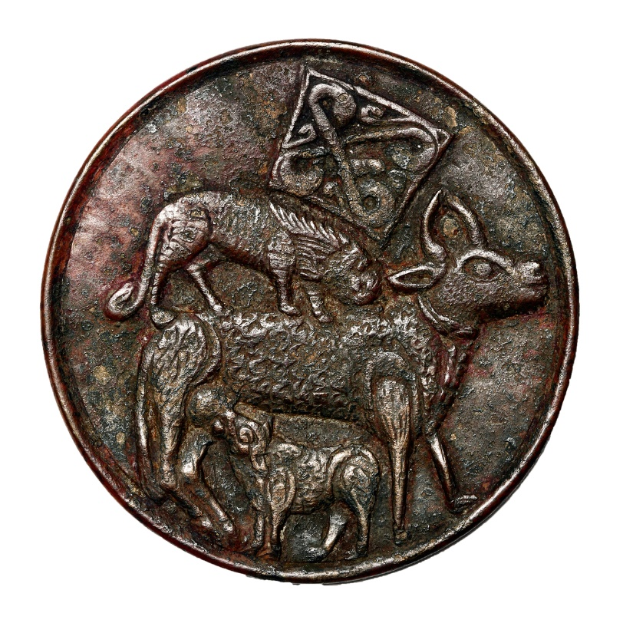
Bronze mirror with animal-combat motif, c. 1100, 8.5 cm diameter, Afghanistan
https://www.davidmus.dk/en/collections/islamic/cultural-history-themes/symbolism/art/71-1979

This is the back of a mirror that depicts a cow or ox nursing its young while being attacked by a lion. It has been cast in bronze.
The symbols here are the lion, the ox, and its calf, as well as the crest that is on top of the lion. The crest and the lion likely symbolize a powerful ruler, both invoking a natural power (the lion) and a dynastic one (the crest). The ox is something servile and agricultural and so the message is clear about the power dynamic of ruler to ruled. However, the presence of the young calf nursing may be a sign of regeneration. There is hope in future generations, both for their own lives, and for the living requirements (i.e., food) of the powerful ruler.

